**###BeginCaseStudy###**

**Testlet 1**

**Background**

You are developing an online shopping web application.

**Business Requirements**

A user is not required to provide an email address. If a user enters an email address, it must be verified to be a valid email address. Information about the first product on the product page must fade out over time to encourage the user to continue browsing the catalog. Administrators must be able to edit information about existing customers. Administrators also must be able to specify a default product on the product page.

**Technical Requirements**

**General:**

The web store application is in a load-balanced web farm. The load balancer is not configured to use server affinity. The web store application isan ASP.NET MVC application written in Visual Studio.

**Products:**

The value of the product ID property must always be greater than 0. The Products page for mobile devices must display to mobile users. The Products page for desktop devices must display to desktop users.

**Storage:**

The data must be stored in a serialized XML data format. Serialized objects must be schema-independent.

**Exception handling:**

Exceptions originating from IIS must display a page with support contact information. Some page links expire, and users who access these links encounter 404 errors. Exceptions must be logged by using the WriteLog method of the Utility class.

**Browser and device support:**

The application must support image format conversions from .bmp to .jpeg for mobile devices. The application must support image format conversions from .bmp to .png for desktop devices.

**Application Structure**

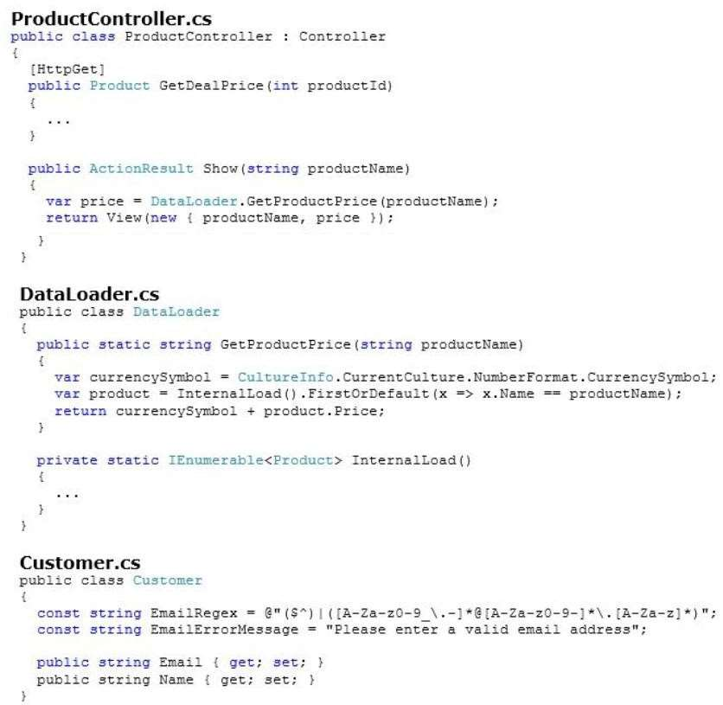

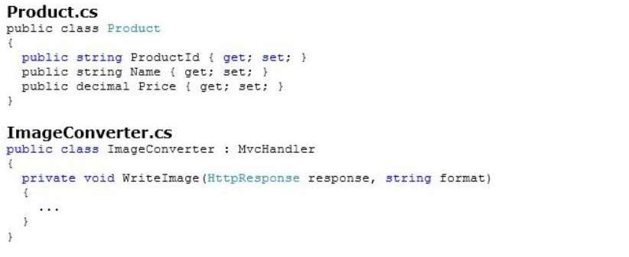

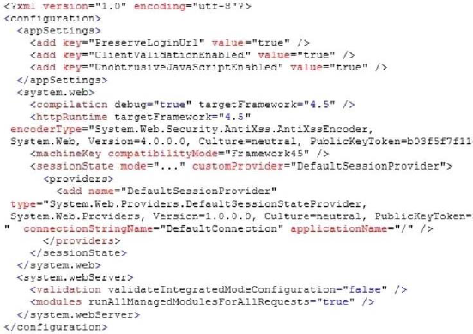

**###EndCaseStudy###**

1. HOTSPOT

You need to implement the mobile device support requirements. How should you build the ProcessRequest method? (To answer, select the appropriate options in the answer area.)

Hot Area:

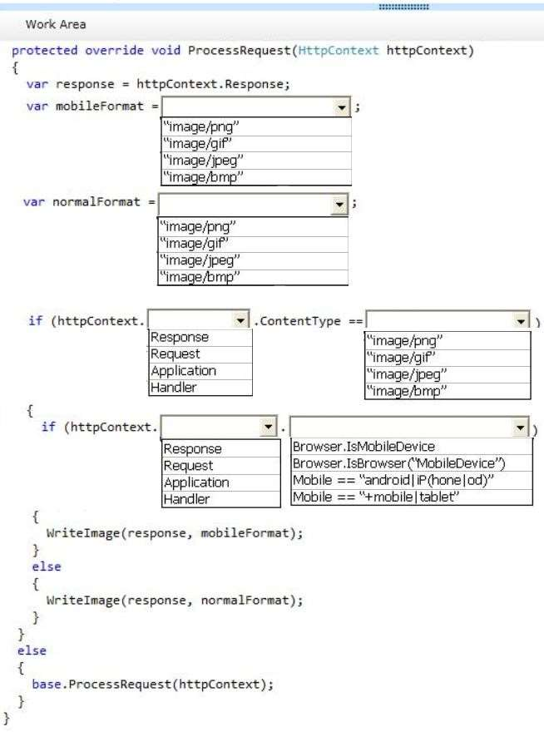

Answer

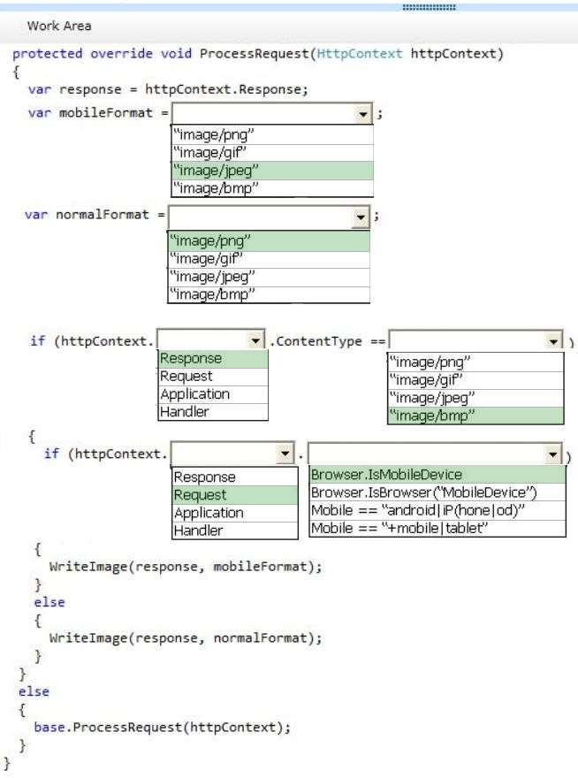

1. The GetDealPrice method must be called by using Ajax. You need to get the price of a product by using the GetDealPrice method of the ProductController. Which code segment should you use? (Each correct answer presents a complete solution. Choose all that apply.)

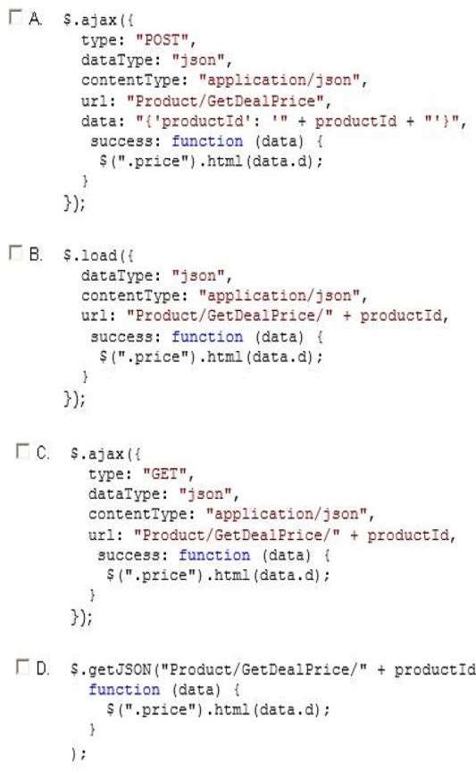

1. Option A
2. Option B
3. **Option C**
4. **Option D**
5. You need to update the routes to ensure that a product is always displayed on the product page. Which code segment should you use?

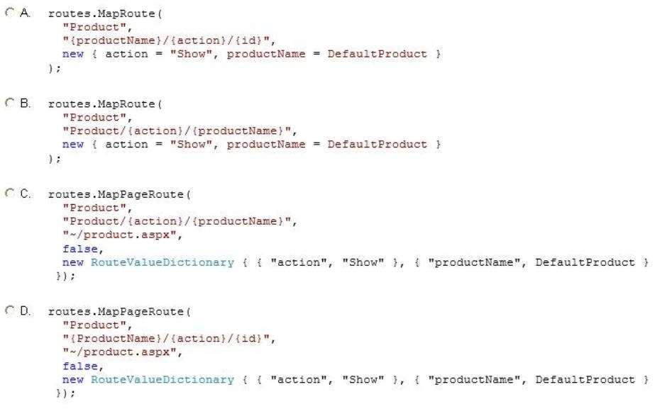

1. Option A
2. **Option B**
3. Option C
4. Option D
5. You need to configure session storage in the web.config file to meet the technical requirements for scalability. Which SessionState mode should you use? (Each correct answer presents a complete solution. Choose all that apply.)
6. **StateServer**
7. InProc
8. AutoDetect
9. **SqlServer**
10. You need to implement client-side animations according to the business requirements. Which line of code should you use? (Each correct answer presents a complete solution. Choose all that apply.)
11. $(“body h1:nth-child(1)”).fadeIn(1000);
12. **$(“body h1:nth-child(1)”).fadeOut(1000);**
13. **$(“body h1:nth-child(1)”).animate({ opacity: 0 });**
14. $(“body h1:nth-child(1)”).animate({ opacity: 1 });
15. You updated the web.config file with the HTTP run-time value required to display an alternative version of the site. You need to ensure that the correct page displays to the users.Which code segment should you use to update the controller?
16. If (Request.IsTabletDevice)
17. If (Request.Browser.IsBrowser(“Mobile”))
18. If (Request.UserAgent[“Tablet”])
19. **If (Request.Browser.IsMobileDevice)**
20. When users attempt to retrieve a product from the product page, a run-time exception occurs if the product does not exist. You need to route the exception to the CustomException.aspx page. Which method should you add to MvcApplication?

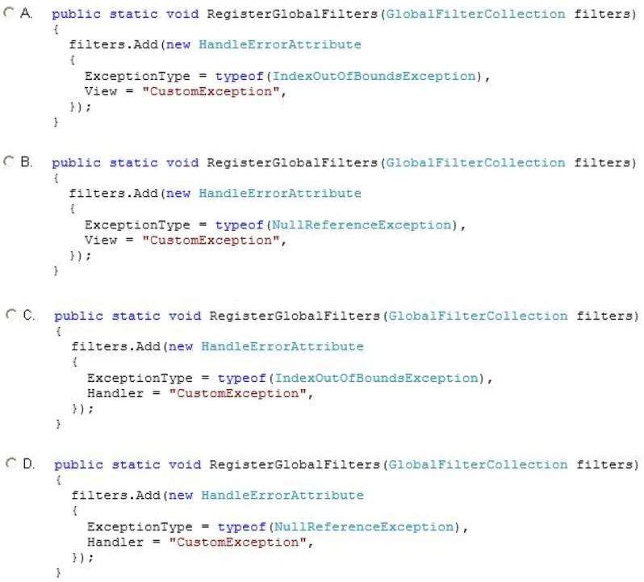

1. Option A
2. **Option B**
3. Option C
4. Option D
5. You need to implement the business requirements for managing customer data. What should you do? Each correct answer presents part of the solution. Choose all that apply.
6. **Add a folder named Customer to the Views folder. Then create a view inside this folder named Edit.aspx.**
7. Add a folder named EditCustomer to the Views folder. Then create a view inside this folder named Catalog.aspx.
8. **Add a class named CustomerController to the Controllers folder. Then add a method named Edit to the class.**
9. Add a class named Catalog to the Controllers folder. Then add a method named EditCustomer to the class.
10. You need to modify the application to meet the product Id requirement. What should you do?
11. Modify the RegisterGlobalFilters method of the Global.asax.cs file as follows. Contract.Assume<ArgumentException>(productId != 0);
12. **Modify the GetDealPrice method of ProductController as follows. Contract.Requires<ArgumentException> (productId > 0);**
13. Modify the RegisterGlobalFilters method of the Global.asax.cs file as follows. Contract.Requires<ArgumentException>(productId > 0);
14. Modify the GetDealPrice method of ProductController as follows.

Contract.Assume<ArgumentException> (productId != 0);

1. An advertising campaign was recently launched. Some of the ads contain a link to products that no longer exist or have IDs that have changed. You need to ensure that all product links display a product. Which code segment should you use to configure the route?

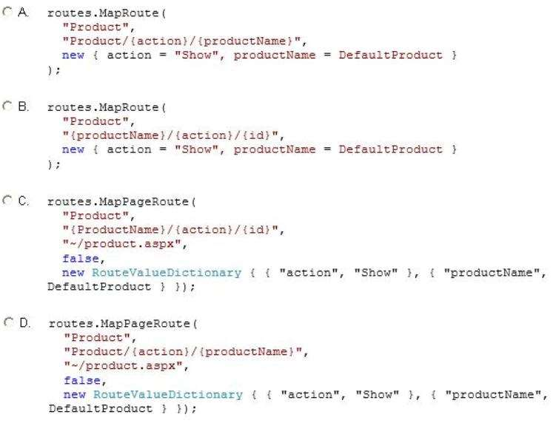

1. **Option A**
2. Option B
3. Option C
4. Option D
5. You need to add a method to the ProductController class to meet the exception handling requirements for logging. Which code segment should you use?

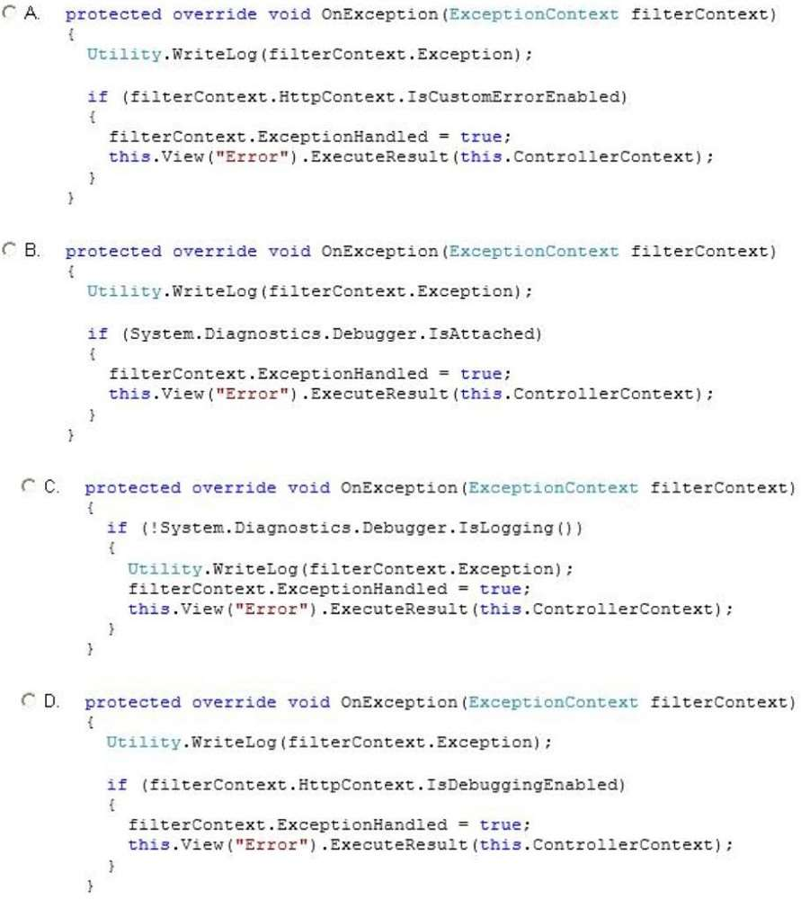

1. **Option A**
2. Option B
3. Option C
4. Option D
5. You need to implement the requirements for handling IIS errors. What should you do?

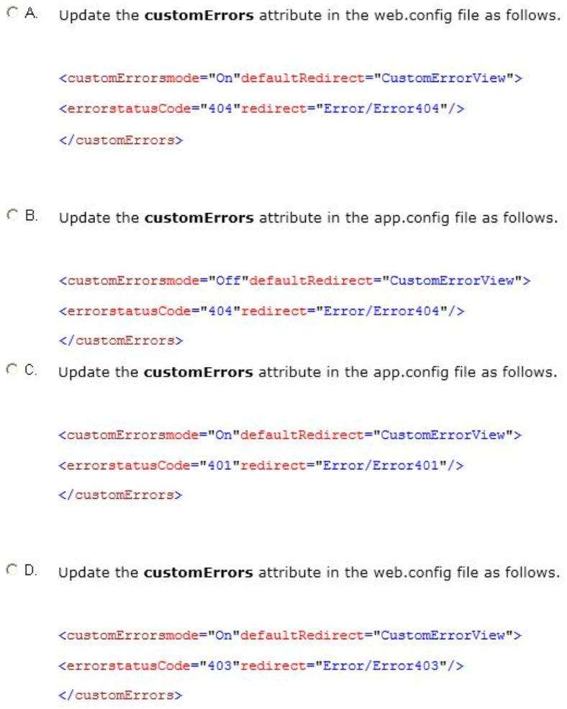

1. **Option A**
2. Option B
3. Option C
4. Option D
5. You are designing a Windows Communication Foundation (WCF) service that uses the Product class. You need to update the class to meet the storage requirement. What should you do? (Each correct answer presents part of the solution. Choose all that apply.)
6. **Mark the Product class with the DataContract attribute.**
7. Mark the public members of the Product class with the DataContractFormat attribute.
8. Mark the Product class with the CollectionDataContract attribute.
9. **Mark the public members of the Product class with the DataMember attribute.**
10. You need to ensure that new customers enter a valid email address. Which code should you use? (Each correct answer presents part of the solution. Choose all that apply.)
11. **[RegularExpression(EmailRegex, ErrorMessage = EmailErrorMessage)]**

**[DataType(DataType.EmailAddress)]**

**public string Email(get;set;)}**

1. [RegularExpression(EmailRegex, ErrorMessage = EmailErrorMessage, ErrorMessageResourceType = DataType.EmailAddress)]

[ComplexType]

public string Email(get;set;)}

C. <: @Html.Raw (m => m.Email) %>

D. **<: @Html.TextBoxFor (m => m.Email) %>**